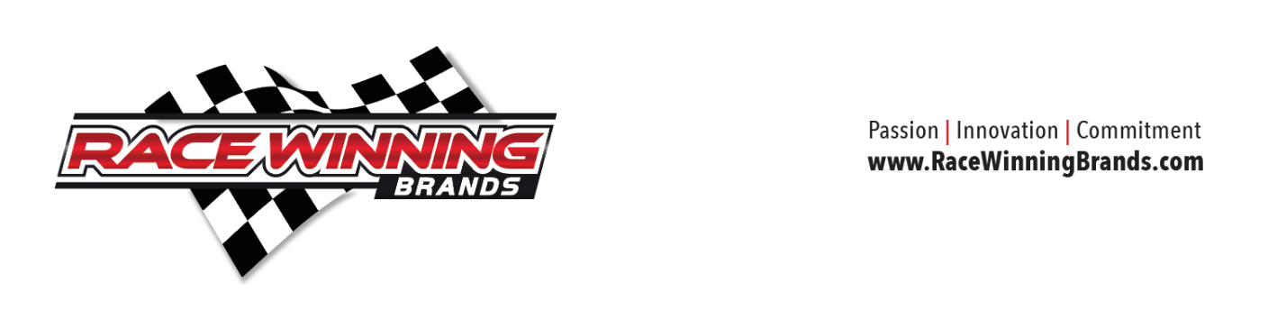

Race Winning Brands Welcomes Industry Veteran Vic Wood to the Team

June 23, 2021 - Mentor, OH – Race Winning Brands (RWB), a leading manufacturer of high-performance engine components for the automotive and powersports aftermarkets, is proud to welcome industry veteran Vic Wood as a Regional Tech Support Manager.

Wood comes to Race Winning Brands with over 40 years of experience in the automotive aftermarket. A native of Australia, Vic came to the U.S. in 2000 and has established a decorated history including direct involvement with several long-established racing component manufacturers such as Hedman Performance Group, B&M / Mcleod Industries and Weld Wheels, as well as the SEMA Industry Councils.

Wood is committed to the engine building and racing sectors both professionally and personally. His contributions to the industry have been reflected and actively recognized by organizations like SEMA, MPMC and NHRA dating back to 2005, but his personal racing achievements are equally notable. Prior to coming to the U.S., Vic was a winning drag racer and dirt oval competitor in both Midgets and Sprint Cars, building many of his own engines. His racing interest has not wavered, as he can still be found these days in the pits with his good buddy Joe Gaerte. Wood also drove a 245-mph roadster at Bonneville Speed Trials and remains an avid hot rodder with his ‘64 Chevy C10 pickup powered by a blown 410ci Dart Machinery-equipped engine. On the drag racing front, Vic is a familiar face to most of the NHRA crew chiefs through his past roles and will continue that role with RWB.

“In our ongoing focus of having experienced industry people calling on engine builders, this is a perfect fit for RWB,” commented Bob Bruegging, Race Winning Brands’ CEO. “Vic knows his way around a race car – in the pits and at the shop – and brings tons of energy and product knowledge to our company. Calling on engine builders directly is how we learn what they need and how they learn what we can do for them.”

By continuing to invest in top industry talent, Wood’s hire reinforces RWB’s commitment to its current automotive business platforms, while also emphasizing new growth. Wood will be spending time servicing automotive engine builders, performance shops, and distributors throughout the mid-West, highlighting RWB’s consistent and strong efforts to better serve its customers.

“I am excited to join Race Winning Brands and look forward to the challenges ahead,” explained Wood. “The role I have been offered provides me with some truly great and exciting opportunities to visit existing and future customers directly. I really enjoy the face-to-face contact in a customer’s place of business which provides the opportunity to see and listen to their needs on the front line. This environment, along with being at the racetrack for key racing events, is something I have greatly enjoyed over the years and is where I have spent most of my life in one role or another.”

Wood will remain based out of the Kansas City area to serve the mid-West territories representing RWB effective immediately.
###
About Race Winning Brands
Race Winning Brands (RWB) is the leading manufacturer of racing and high-performance parts sold to automotive and powersports markets. RWB is the preferred source for high-end pistons, engine blocks, cylinder heads, intake manifolds, connecting rods, crankshafts, clutches and other engine and driveline-related performance components. RWB markets its products through multiple prominent brands including JE Pistons, Wiseco Performance Products, K1 Technologies, Diamond Pistons, Trend Performance, Rekluse Motor Sports, CV4, X2 Valvetrain, MGP Connecting Rods, ProX Racing Parts, Dart Machinery, Manley Performance Products, and Victory 1 Performance. RWB sells to a diverse and unmatched customer base of professional and sportsman racers, engine builders, enthusiasts, OEMs, automotive and powersports dealers and wholesale distributors. RWB is headquartered in Mentor, Ohio with sales offices and manufacturing operations in strategic locations throughout the United States, Canada, and Europe. For more information, please visit racewinningbrands.com

